Airline Passenger Demand Forecasting Project

1. Project Statement
Airlines and aviation authorities require accurate forecasts of international passenger demand to optimize resource allocation, scheduling, pricing, and long-term planning. Using historical passenger and departures data, this project aims to build predictive models that forecast future passenger traffic at a monthly level.

2. Business Goal
- Primary Goal: Forecast monthly international passenger demand for the next 12–24 months.
- Why it matters:
  - Helps airlines adjust flight schedules and fleet utilization.
  - Supports airports in planning gate/crew resources and infrastructure.
  - Assists governments and tourism boards in anticipating travel demand.
- Success Criteria: Models achieve ≤10% MAPE on holdout forecasts and generate stable, interpretable forecasts for decision-making.

3. Data Sources
International_Report_Passengers.csv
  - Contains monthly passenger counts by airport and world region.
  - Time coverage: 1990–2020.
(Both datasets come from U.S. Bureau of Transportation Statistics / FAA reporting — though you uploaded local copies from kaggle.)

4. Tools & Technologies
- Programming: Python
- Libraries:
  - pandas, numpy → Data wrangling & aggregation
  - matplotlib, seaborn → Data visualization
  - statsmodels → SARIMAX (time-series forecasting)
  - scikit-learn → Regression (RandomForest, feature engineering)
- Workflow/Environment: Jupyter Notebook / Google Colab
- Version Control: Git/GitHub
- Power BI : Interactive dashboards

5. Project Workflow
- Problem Definition → Identify forecasting need & business requirements.
- Data Extraction → Load CSV datasets into pandas, parse dates, clean missing values.
- Exploratory Data Analysis (EDA):
  - Trend/seasonality analysis of passenger counts.
  - Airport-level vs aggregate analysis.
- Feature Engineering:
  - Time features (month, year).
  - Lag features (1, 2, 3, 6, 12 months).
  - Rolling means (short-term vs long-term demand).
- Modeling:
  - ML approach: RandomForest regression with engineered features.
  - Compare performance on holdout (last 24 months).
- Model Evaluation:
  - Metrics: MAE, RMSE, MAPE.
  - Visual comparison of predicted vs actual passengers.
- Forecasting & Deployment:
  - Generate 12–24 month forecasts.
  - Save outputs as CSV/dashboard for stakeholders.

6. Data Extraction (PHASE1_TEAMBLACK.ipynb)
- Source: CSV files (International_Report_Passengers.csv).
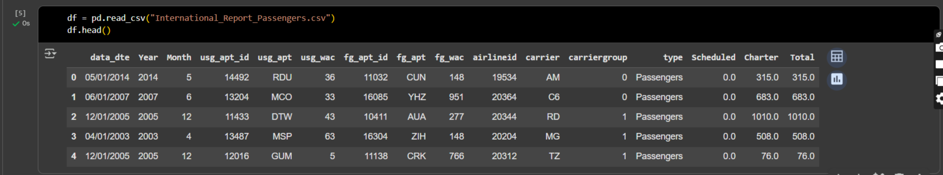
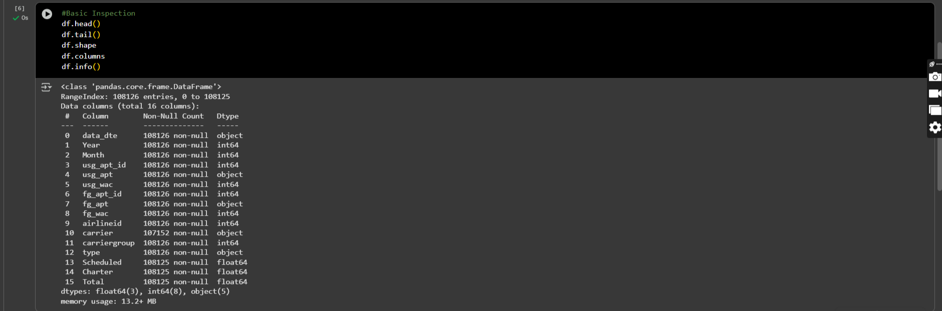
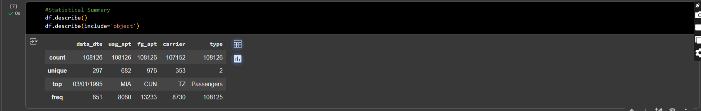
- Transformation:
  - Convert date column to monthly frequency.
  - Aggregate passenger counts across all airports to get total monthly demand.
  - Similarly, aggregate departures if needed for exogenous features.

7. Data Dictionary (DATA DICTIONARY.xlsx)
Column Name | Description
data_dte | Date of record (monthly).
carrier_name | Airline/operator name.
carrier | Carrier code (IATA/ICAO).
region | World region of passenger traffic.
airport | Airport name.
airport_code | IATA airport code.
city | City of the airport.
country | Country of the airport.
passengers | Number of passengers recorded for that airport/carrier/region/date.
freight | Cargo weight (if applicable).
mail | Mail weight (if applicable).
(Main column for forecasting = passengers.)

